MEMBRANE MODEL: The Bubble Lab

The cell’s plasma membrane is a phospholipid bilayer with protein molecules imbedded in it. The protein molecules transport other molecules through the membrane and into or out of the cell. All of the membranes in the cell (nuclear envelop, endoplasmic reticulum, membranes in the chloroplasts and mitochondria) are essentially the same as the plasma membrane.

The phospholipids bilayer is made of two layers of molecules. Each phospholipids molecule has a polar (hydrophilic) head and two non-polar (hydrophobic) tails. The hydrophobic tails of the two layers repel water and are attracted to each other. They form the inside of the membrane bilayer “sandwich” while the polar heads are on the outside closest to the water.

Soap bubbles are bilayers very similar to phospholipids membranes, so they can be used to investigate some of the properties of the cell membrane. The soap bubble bilayer is made of molecules with a hydrophilic head and a hydrophobic tail, except that the surrounding medium (air) is non-polar, so the tails of the bilayer face outward and the polar heads form the inside.

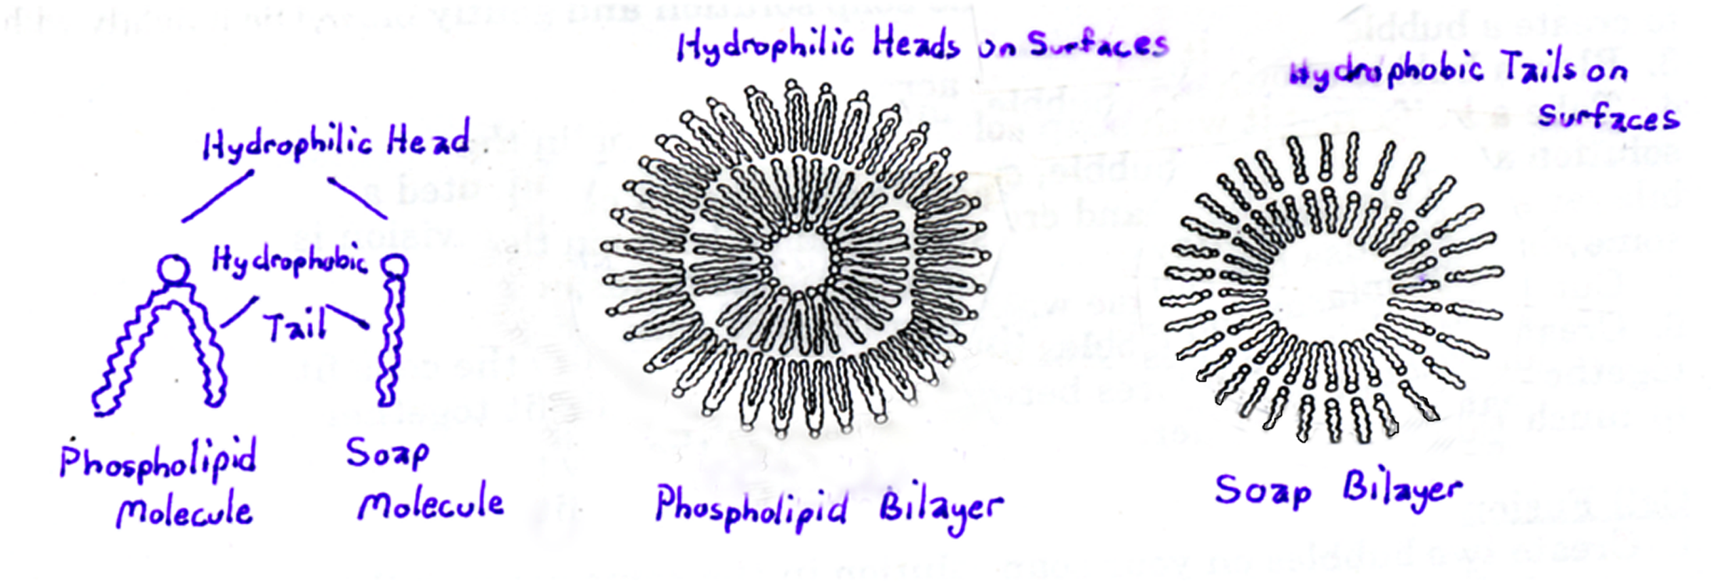
Materials
Flat pan String
Straightened paper clip Thread circle
Plastic knife
Drinking straw and string “membrane holder”
Soap mixture
(900 ml water + 100 ml Joy liquid soap + 25 ml glycerin or corn syrup)

Procedure
- Pour soap solution to about 1 cm. depth in your pan. Be careful not to make froth as you pour.
- Holding the straws of the membrane holder, immerse it into the pan of soap solution. Raise it out of the pan and allow the excess soap to drip off. Hold up the soap film-filled membrane holder and demonstrate the following characteristics of a lipid bilayer.
- Fluidity: The theory of the structure of the cell membrane is called the Fluid Mosaic Model. This means that the membrane is made of a pattern of many small molecules that are moving around and shifting position.
- Can you see the light shining of the surface of the soap film? You should be able to see movement in the light pattern, demonstrating that the molecules of the film are constantly in motion.
- Flexibility: A lipid bilayer is a fluid arrangement within which the molecules can move freely through the plane of the bilayer. They can reorganize themselves into almost any shape without losing the contacts that satisfy their mutual attraction.
- Twist the two straw handles in opposite directions and bend the film into different configurations.
- What happens to the soap film?

The soap bilayer is actually less flexible than a cell membrane because a cell membrane is supported on both sides, one side by the cytoplasm and the other by lymph or other tissue fluids. So, whatever you are doing to the soap film, plus more, can be done to cell membranes without breaking them.
- Self-Sealing: Remember that the membrane is not a solid. It is made of two layers of many molecules attracted to each other.
- Make another film in the membrane holder. Take the straightened paper clip and dip it in the soap solution. Stick the paperclip in the membrane and pass it through to the other side.
- Did the membrane seal around the paperclip?
- Make another film. Stick a dry paperclip through the membrane.
- What happens? Why?
- Make another film. Dip your finger into the soap solution, making sure that it is well covered, and stick it into the membrane. Remove your finger from the membrane.
- What happens to the membrane when you remove your finger? Can the membrane heal around small punctures?
- Transport Proteins: In a cell membrane, small molecules such as water can sometimes move into the cell through small spaces in the lipid bilayer. Larger polar molecules cannot pass through the membrane because of the non-polar tails in the interior of the membrane. The only way these molecules can pass in and out of the cell is through channels created by protein molecules in the membrane. The proteins form a polar tunnel through which the molecules can pass.
- Take a small piece of thread and tie it into a circle with the diameter of a dime. ---Form another film in your membrane holder.
--Dip your thread circle in the soap solution and carefully stick it into the membrane.
--Pop the inside of the thread circle with a dry object. You now have a model of a transport protein in a cell membrane.
- To demonstrate the fluidity of the membrane, stick your finger in the pore created by the thread circle and gently move it around the membrane.
- Cell Division: Cells divide when an organism is growing, when tissues need to be repaired, or when the surface area to volume ratio becomes too small (i.e. the cell grows too large).
- Take a straw and dip the end in the soap solution. Hold it just above the surface of the soap solution and gently blow to create a bubble. Make a bubble about 8-10 cm across.
- Take a knife, wet it with soap solution, and starting in the solution at one side of the bubble, cut the bubble in half. You have created a bilayer across the middle and made two bubbles. (Cell division is somewhat similar to this.)
- Cut the two new bubbles in half. Keep dividing the bubbles until you have 10-80. Notice how the bubbles fit together without any spaces between them. Your cells fit together in much the same manner.
- Cell Fusion: There are circumstances in a cell where two membranes fuse into a single larger structure. Researches even fuse two cells together in a laboratory to create a larger cell with properties of each. (e.g. They can fuse an antibody-making cell with a cancer cell to get cells that keep multiplying and making antibodies.)
- Use a straw to create a few bubbles in your soap solution. Coax the bubbles toward each other and try to get them to fuse into a single big bubble.

